**CHAPTER 1**

**INTRODUCTION**

**1.1 INTRODUCTION**

The emergence of chat applications has revolutionized interpersonal communication, shaping our daily routines significantly. In a market brimming with a diverse array of chat platforms, each boasting distinctive features and functionalities, users enjoy a wide spectrum of choices. This dynamic landscape fuels fierce competition among companies, spurring relentless innovation as they vie to introduce novel features and refine user experiences with each iteration. This competition has catapulted some firms to the forefront of the industry, yielding substantial revenues and supporting sizable workforces. However, amid mounting concerns surrounding data security breaches, safeguarding user data against unauthorized access has become paramount for companies operating in this sphere. Globally, developers are engaged in a perpetual quest to enhance the user experience of chat applications while streamlining development processes for increased efficiency. To this end, technology stacks play a pivotal role, furnishing developers with comprehensive frameworks for expedited web application development. Leveraging stacks like MERN, which are founded on JavaScript, developers gain access to end-to-end solutions for constructing robust web applications that seamlessly bridge browsers and databases. Recognizing the demand for a reliable and cross-platform chat application, our team embarked on a project to develop such a solution using the MERN stack. By harnessing the unique strengths of each technology within the stack, our aim was to craft a seamless and intuitive user experience. The culmination of our endeavors is Lifeline Messenger, a social networking tool leveraging cutting-edge technologies to facilitate seamless communication and media sharing. This platform provides users with a comprehensive suite of features, including messaging capabilities one to one chat, group chat and media sharing. Chat applications have become ingrained in our daily lives, inundating the market with myriad options. However, amidst this abundance, ensuring data security remains paramount, given the escalating threat of data breaches. As such, chat application providers must prioritize user data security and implement robust measures to mitigate the risk of third-party breaches. The foundational architecture of a chat system should enable seamless and concurrent message exchanges, a requirement aptly fulfilled by the MERN concept.

**1.2 PROJECT CATEGORY**

The " real-time chat application " project is categorized under Application or System

Development, involving the creation of software enabling instantaneous text-based communication over the internet. This application facilitates seamless interaction between users in real-time, fostering collaboration and connectivity across various platforms and devices. It encompasses designing intuitive user interfaces, implementing robust backend systems for message handling and delivery, and ensuring secure data transmission. Through meticulous development processes and continuous testing, the application aims to deliver a reliable and user-friendly platform for engaging in instant communication, catering to diverse user needs and enhancing digital connectivity in today's interconnected world.

**1.3 OBJECTIVES**

**Real-Time Communication**: The primary goal of a chat application is to enable users to engage in real-time communication. This involves the instant exchange of text messages, ensuring that messages are delivered and received promptly, creating a seamless conversational experience.

**GUI**: Easy to use GUI (Graphical User Interface), hence any user with minimal knowledge of operating a system can use the software

**Unlimited clients**: “N” number of users can be connected without any performance degradation of the server.

**User Engagement**: To keep users active and invested in the platform, chat applications provide various features to enhance engagement. These may include multimedia sharing (photos, videos, files), emojis, stickers, GIFs, and reactions. Such features add richness to conversations and make interactions more enjoyable.

**Scalability**: As the user base grows, the application should be able to handle increased traffic without sacrificing performance. Scalability ensures that the chat service remains responsive and reliable, even during peak usage periods.

**Security**: Protecting user data and privacy is paramount. Chat applications employ robust security measures such as end-to-end encryption to safeguard messages from unauthorized access. Secure authentication mechanisms prevent unauthorized users from accessing accounts, ensuring that communication remains private and confidential.

**Reliability**: A reliable chat application minimizes downtime and ensures uninterrupted communication. This involves robust infrastructure, efficient message delivery mechanisms, and proactive monitoring to detect and resolve issues promptly. Users should be able to rely on the application for their communication needs without experiencing frequent disruptions.

**1.4 STRUCTURE OF THE REPORT**

1. **Introduction**: In this section, we provide a succinct overview of our human drowsiness detection project, outlining its objectives and significance. We highlight the project's aim to develop an efficient drowsiness detection system and its potential impact on user convenience and productivity.
2. **Literature Review**: The literature review delves into existing research and discourse surrounding drowsiness detection system. We analyze the evolution of drowsiness detection technology, discussing advancements, user experiences, and pertinent security and privacy concerns.
3. **Proposed System**: This chapter outlines our proposed drowsiness detection system, detailing its functionalities and the technologies utilized for its implementation. We elucidate the system's capabilities and how it addresses user requirements.
4. **Requirement Analysis and System Specification**: Here, we conduct a feasibility study of our proposed system and provide a detailed software requirement specification. We discuss the chosen SDLC model and its relevance to the project's development.
5. **Implementation**: In this section, we present an overview of the languages, tools, and technologies employed for implementing the drowsiness detection system. We delve into the libraries and algorithms utilized, offering insights into the implementation process and key modules.
6. **Testing and Maintenance**: This chapter focuses on testing techniques and methodologies utilized to ensure the functionality and reliability of our drowsiness detection system. We discuss unit testing, integration testing, functional testing, usability testing, and performance testing, along with details of the test environment.
7. **Results and Discussions**: Here, we provide a summary of the various modules comprising the voice assistant system and discuss the outcomes of our project. We analyze the results, interpret their implications, and offer insights into the findings.
8. **Conclusion:** In the conclusion, we encapsulate the project's objectives, achievements, and contributions. We reflect on key findings, discuss potential future research directions, and underscore the significance of our work.
9. **References:** The references section includes citations of relevant research papers, articles, and sources used throughout the report, ensuring transparency and academic integrity.

**CHAPTER 2**

**LITERATURE REVIEW**

**2.1 Literature Review**

S. Sharma.[1] have been working hard to create better ways for people to talk and work together online. Author proposed how a special kind of chat app, made with the MERN stack, can also let people have meetings online. Author going to see what other experts have said about similar topics and technologies in their papers and works. This will help us understand more about this area and how we can make it even better.

R. Shah, H. Gajera:[2] have worked upon comparing different chat apps that let people talk in real time. We're looking at how well they work, how many people can use them at once, and how easy they are to use. By doing this, we can understand what makes a chat app good and what problems they might face. Author also used strong technology behind the scenes and using fast communication methods are really important for making chat apps work smoothly.

K. Trabelsi and L. Ben Romdhane.[3] talked about making tools that help teams work together when they're not in the same place. Author looked at the problems teams have when they work remotely and suggests ways to help them communicate and work well together. The study says it's important to have tools that let teams chat and have video meetings all in one place, so they can get more done.

A. Patil and P. Yadav:[4] talked about something called the MERN stack and how it's used to make websites that update in real-time. We looked at the good things about using MongoDB, Express.js, React.js, and Node.js together for real-time talking online. Author also talked about the problems he might face and give tips on how to build websites that can handle lots of users and respond quickly.

A. Hameed, S. Hassan:[5] aimed at different ways people can have meetings online using video. We check out different tools and platforms for online meetings, seeing how good they are and if they're right for different kinds of meetings. In the research, features are important for video meetings in chat apps, like being able to share your screen, record the meeting, and chat with others while you're in the meeting.

K. S. Prasad and R. Kumari: [6] has proposed how to make chat apps that can handle lots of people talking at the same time. We talk about picking the right tools and ways to set up the app so it responds quickly. We also check out how different technologies and databases perform, to help us make chat apps that work well even when lots of people are using them.

A. Bhardwaj and S. Singh [7] has explained how a new chat app offers a more flexible and improved way for people to talk. It's built using the latest technology to ensure it's reliable. The app has many benefits, like instant messaging, secure communication, and group chats, making it appealing for organizations wanting private communication tools. Extra features, such as conference calls, video chats, and location sharing, will be added based on what users want and need.

R. Kumar and K. Singh: [8] has explained the importance of creating a chat app that's real-time and can be used by lots of people across different locations. It explains that the app is built using Node.js for the server and MongoDB for the website, which provides a clear framework for development.

**2.2 Research Gap**

1. **Scalability:** Investigate innovative approaches to manage high user loads while ensuring low latency, possibly through dynamic scaling mechanisms or optimized message distribution algorithms.
2. **User Experience:** Explore interface design improvements for enhanced accessibility and usability across devices, employing real-time user feedback analysis to identify pain points and preferences.
3. **Security:** Research advanced encryption and authentication methods to fortify data protection, addressing vulnerabilities and ensuring robust security measures against evolving threats.
4. **Compatibility:** Explore comprehensive strategies for seamless communication among disparate chat platforms, including protocol standardization efforts and middleware solutions for efficient integration.
5. **Emerging Tech Integration:** Examine how real-time chat can enrich experiences in AR, VR, and IoT realms, assessing integration feasibility and exploring novel applications to enhance user engagement and utility in these environments.

**2.3 Problem Formulation**

* **Security Concerns:** Users may be hesitant to use chat applications due to concerns about data privacy and security breaches.
* **User Authentication**: Implement a secure authentication system to allow users to register, log in, and manage their accounts securely.
* **Encryption and Security**: Implement end-to-end encryption and other security measures to protect user data and ensure privacy.
* **User Presence Status**: Display the online/offline status of users to indicate their availability for communication.
* **Group Chat:** Support group conversations where multiple users can participate simultaneously.

**CHAPTER 3**

**PROPOSED SYSTEM**

**3.1 Proposed System**

The proposed system aims to develop a real-time chat application to facilitate instant communication among users. In today's fast-paced world, the need for seamless and efficient communication tools has become paramount. This project seeks to address this need by creating a robust platform that enables users to exchange messages in real-time, enhancing collaboration and connectivity.

* **User Authentication**: Secure authentication mechanisms to verify user identities and protect against unauthorized access.
* **Real-Time Messaging**: Implementation of messaging protocols to enable instant communication between users.
* **Encryption**: End-to-end encryption to ensure the confidentiality and integrity of user messages.
* **Scalable Architecture:** A scalable infrastructure capable of handling a large volume of concurrent users and messages.
* **Cross-Platform Support:** Compatibility with various devices and operating systems to reach a wide user base.
* **System Architecture:** The system will adopt a client-server architecture, where the server will be responsible for managing data processing and communication between clients. The client-side application will feature a Graphical User Interface (GUI) to facilitate user interaction.

**Technologies:**

* MERN Stack: MongoDB will serve as the database solution, ensuring scalability and robustness. Express.js will handle server-side logic, while React.js will power the client-side interface. Node.js will facilitate server-side scripting.
* WebSocket Protocol: WebSocket will be utilized to enable real-time, full-duplex communication between clients and the server.
* Encryption: End-to-end encryption will be implemented to secure user data and communications.
* Open-Source Libraries: Various open-source libraries and frameworks will be utilized to enhance development efficiency and deliver a feature-rich user experience.

**3.2 Unique Features of The System**

1. **Group Chats:** Enables conversations with multiple participants simultaneously, fostering collaboration and communication within teams or communities.
2. **Typing Indicators:** Shows when another user is typing, indicating that they are composing a message.
3. **Encryption and Security Features**: Provides end-to-end encryption to protect user privacy and security, ensuring that messages are only accessible to intended recipients.
4. **Message Reactions:** Users can react to messages with emojis or custom reactions to express their feelings or opinions.
5. **File Sharing**: Seamless sharing of files, images, and documents within chat conversations.
6. **Offline Messaging:** Users can send and receive messages even when offline, with messages syncing once an internet connection is available.
7. **Anonymous Chat Mode**: Introduce an anonymous chat mode option where users can engage in conversations without revealing their identities, encouraging open and candid discussions on sensitive topics.

**CHAPTER 4**

**REQUIREMENT ANALYSIS AND SYSTEM SPECIFICATION**

**4.1 Feasibility Study**

Feasibility study is the preliminary study undertaken before the real work of the project starts to ascertain the like hood of the project success. It analyses the possible solutions to a problem and a recommendation on the best solutions to use. It involves the evaluation that how the solution will fit into the corporation. A Feasibility study is defined as a evolution or analysis of the potential impacts of a proposed project or system. A feasibility study is conducted to assist decision makers in determining whether or not to implement a particular project or system. On the basis of result of the initial study, feasibility study takes place. The feasibility study is basically the proposed system in the lights of its workability, meeting user requirements, and effective use of resources and of course, cost effectiveness. The main goal of feasibility study is not to solve the problem but to achieve this scope. In the process of feasibility study, the cost and benefits are estimated with the greater accuracy. It evaluates the benefits of the new system. The feasibility study will contain the extensive data related to financial and operational impact and will include advantage and disadvantages of both current situation and plan. The aim of feasibility study is to see whether it is possible to develop a reasonable cost. At the end of feasibility study a decision is taken whether or proceed or not. Feasibility study is to determine various solution of the problem and then picking up one of the best solutions. It is the measure of how beneficial the development of 13 information system will be to an organization. The study also shows the sensitivity of business to change in the basic assumption.

1. **Economic Feasibility:** For any system if the expected benefits equal or exceed the expected costs, the system can be judged to be economically feasible. In economic feasibility, cost benefit analysis is done in which expected costs and benefits are evaluated. Economic analysis is used for evaluating the effectiveness of the proposed system. In this type of feasibility study, the most important is cost and benefit analysis. As the name suggests, it is as analysis of the costs to be incurred in the system and benefits derivable out of the system.
2. **Technical Feasibility:** In technical feasibility the following issues are taken into consideration.Whether the required technology is available or not. Whether the required resources are available like manpower, programmers, testers and debuggers, software and hardware.
3. **Operational feasibility:** The operational feasibility of a real-time chat application hinges on several critical factors. Successful implementation relies on high user adoption, necessitating a user-friendly interface and effective training. Infrastructure requirements must be met to support the application's load, while seamless integration with existing systems ensures smooth workflows. Scalability is vital for accommodating growth, and robust security measures must be in place to protect sensitive data. Cost considerations, including development, maintenance, and potential savings, play a significant role in determining feasibility. Ultimately, a comprehensive assessment of these factors is essential to gauge the application's operational feasibility within a given context or organization.

**4.2 Software Requirement Specification**

**Introduction**: The Real-Time Chat Application is a software solution designed to facilitate instant messaging and communication among users. This document outlines the requirements for the development of the application, including its scope, purpose, and functionality.

**4.2.1 Data Requirement:**

* **User Data**: Information required for user registration, including username, email, and password.
* **Chat Data:** Storage of messages, including text, multimedia content, timestamps, and sender/receiver information.
* **Metadata:** Additional data such as user preferences, chat settings, and notification preferences.

**4.2.2 Functional Requirement**

* **User Authentication:** Users should be able to register, log in, and securely authenticate their identities.
* **Messaging Features:** Core functionality for sending, receiving, and viewing messages in real-time.
* **User Management:** Ability to add, remove, block, or manage contacts and groups.
* **Notifications:** Push notifications for new messages and alerts.
* **Search Functionality:** Capability to search for specific contacts or groups.

**4.2.3 Performance Requirement**

* **Real-Time Communication:** Messages should be delivered and received instantly, with minimal latency.
* **Scalability:** The system should handle a large number of concurrent users and messages without performance degradation.
* **Response Time:** User interactions, such as sending messages or loading chats, should be responsive and quick.
* **Reliability:** The application should be available and reliable, with minimal downtime or service interruptions.

**4.2.4 Maintainability Requirement**

* **Modular Design:** The application should be modular, allowing for easy maintenance, updates, and future enhancements.
* **Documentation:** Comprehensive documentation of code, APIs, and system architecture to aid in maintenance and troubleshooting.

**4.2.5. Security Requirement**

* **Data Encryption:** Implementation of end-to-end encryption to protect message contents and user data.
* **Secure Authentication:** Robust authentication mechanisms to verify user identities and prevent unauthorized access.
* **Data Protection:** Measures to safeguard user data against unauthorized access, manipulation, or disclosure.
* **Secure Transmission:** Use of secure communication protocols (e.g., HTTPS) to ensure data integrity during transmission.

**4.3 SDLC Model Used**

For a real-time chat application, the Agile software development methodology is often the most suitable choice due to its iterative and flexible approach. Here's why Agile is well-suited for this project:

* **Iterative Development:** Agile allows for the development of the chat application in iterative cycles, known as sprints. Each sprint typically lasts for a few weeks and results in a potentially shippable product increment. This approach enables rapid development and frequent releases, allowing for quick feedback and adaptation based on user input.
* **Flexibility:** Chat applications often require frequent updates and enhancements to meet evolving user needs and technological advancements. Agile's flexible nature allows for changes to be

incorporated easily, even late in the development process, without disrupting the overall project timeline.

* **Emphasis on Individuals and Interactions:** In a real-time chat application, the focus is on facilitating communication and collaboration between users. Agile emphasizes the importance of individuals and interactions over processes and tools, aligning well with the core functionality of the chat application.
* **Continuous Improvement:** Agile promotes continuous improvement through regular reflection and adaptation. At the end of each sprint, the development team conducts a sprint review to evaluate progress and identify areas for improvement, ensuring that the chat application evolves and improves over time.

**4.4 System Design**

**Data Flow Diagrams**



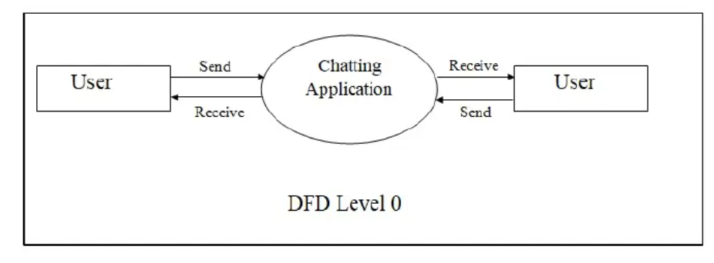

DFD Level 0



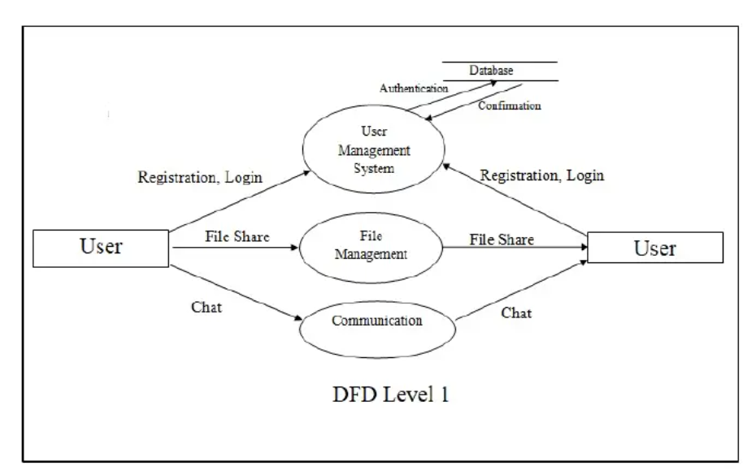



DFD Level 1

**Use Case Diagram**

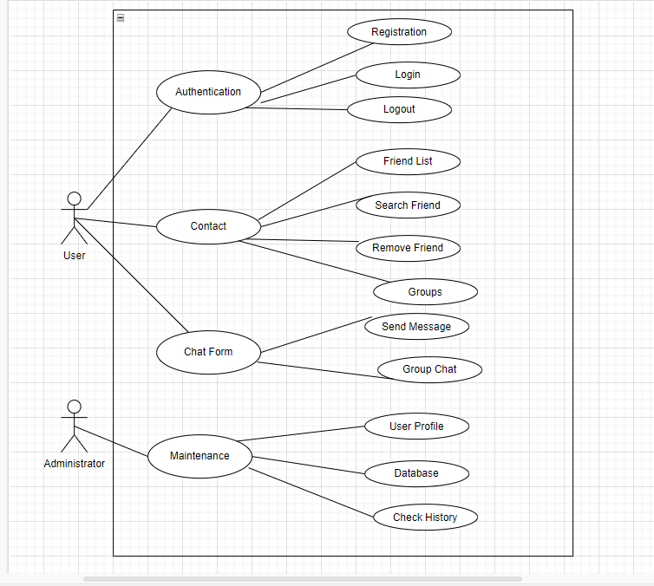

Use Case Diagram

Use Case Table of Chat Application

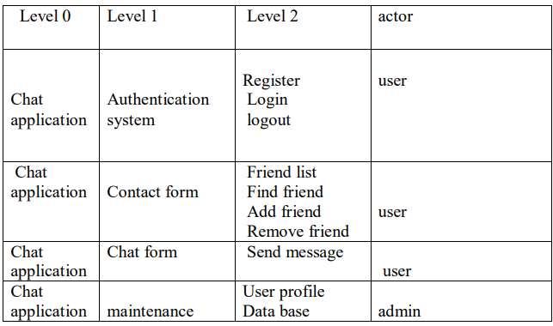

Table 4.2

**4.5 Database Design**

Designing the database for a real-time chat application involves structuring tables to store user information, messages, and any additional data required for the application's functionality. Below is a basic database design for a real-time chat application:

1. **User Table:**

* user_id (Primary Key): An auto-incrementing unique identifier for each user.
* username: The chosen username by the user, unique to ensure no duplicates.
* password: Hashed and salted password for user authentication. Using a strong cryptographic hashing algorithm (e.g., bcrypt) is essential for security.
* email: Email address of the user for communication and account recovery purposes.
* online_status: A boolean field indicating whether the user is currently online or not.

1. **Message Table:**

* message_id (Primary Key): Unique identifier for each message.
* sender_id (Foreign Key): References the user_id of the sender.
* receiver_id (Foreign Key): References the user_id(s) of the receiver(s). For one-to-one chats, this can reference a single user. For group chats, it can reference multiple users.
* content: The actual text content of the message.
* timestamp: Timestamp indicating when the message was sent, useful for displaying message history and sorting messages chronologically.

1. **Database Management:**

* Data Normalization: Normalize the database to minimize redundancy and ensure data integrity. For instance, user information should be stored in a separate table to avoid repeating user details in the message table.
* Indexing: Index frequently queried fields such as user_id, sender_id, receiver_id, and timestamp to optimize query performance and reduce search times.

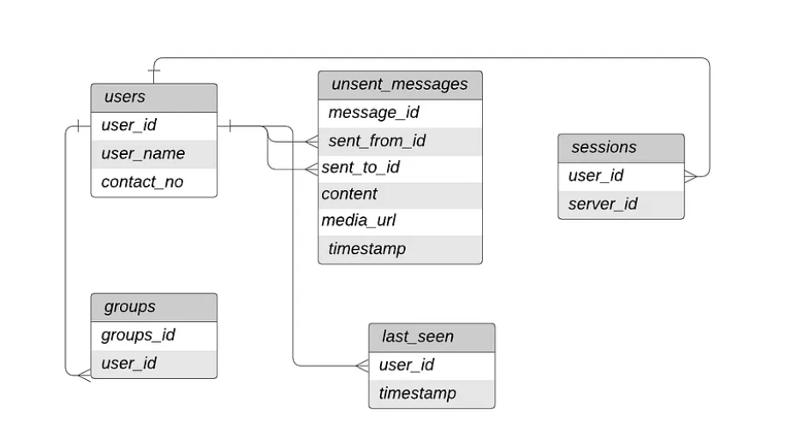**Database Diagram**

Database Diagram

ER Diagram

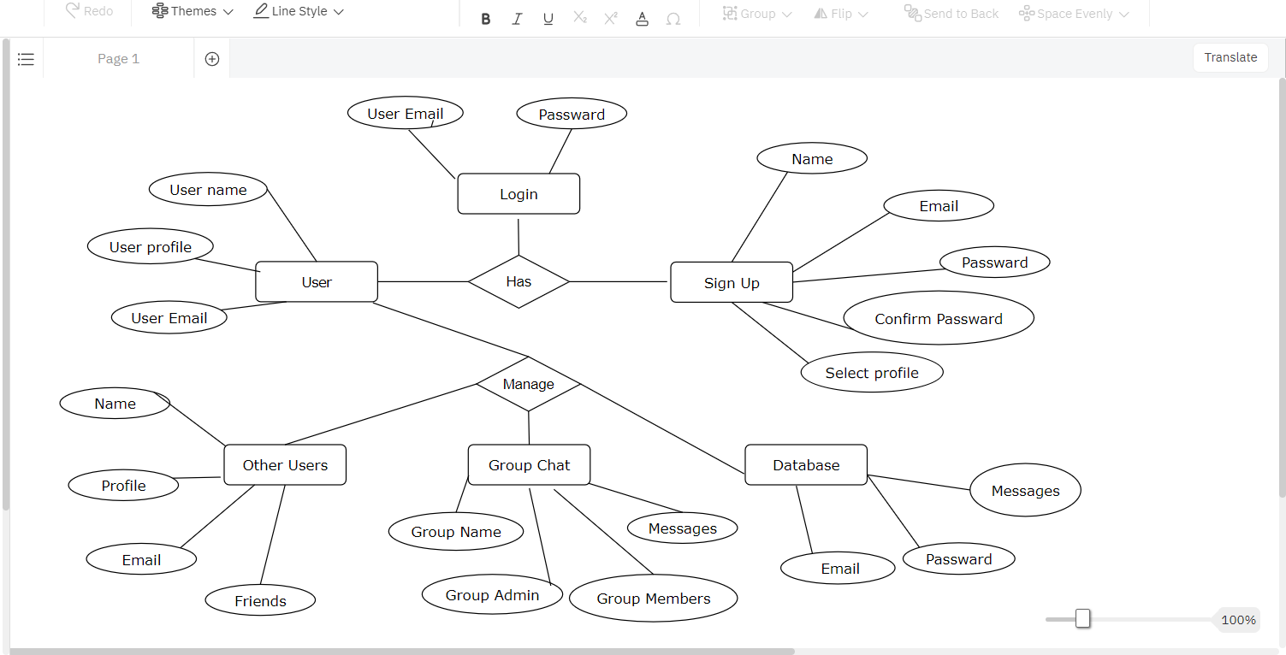

ER Diagram



**CHAPTER 5**

**IMPLEMENTATION**

**5.1 Introduction Tools and Technologies used**

**Technology:** Realtime chat applications interface are created using scripting languages like HTML CSS3, JavaScript, and React.js This markup language makes the application more attractive, useful and user-friendly to use and purchase. Markup languages help make things more engaging and imaginative.

1. **HTML**

HTML is a hypertext markup language. Here is an emerging technology, Cascading Style Sheets, which can eliminate much of the HTML table that can be used to control the layout of a web page. A web designer can separate the header, body, and sidebar sections of a web page by placing each section in a separate cell. Alternatively, the network designer can put each link button on the header and sidebar in a separate cell so that he can set unique attributes for each button. Then, in the body of the page, the network designer can separate the text and graphic elements into different cells to adjust spacing and other properties individually.

1. **CSS**

CSS can be a formatting language to which you want to add style to your page. This can be done by having the associated CSS document in your html page. The page then has selectors and attributes that affect the tags inside your html document. CSS was introduced in 1996. It was created to prevent people from having to repeat a lot of code. is a style sheet language used for describing the presentation of a document written in a markup language such as HTML or XML (including XML dialects such as SVG, MathML or XHTML).[CSS is a cornerstone technology of the World Wide Web, alongside HTML and JavaScript. CSS is designed to enable the separation of presentation and content, including layout, colors, and fonts. This separation can improve content accessibility; provide more flexibility and control in the specification of presentation characteristics; enable multiple web pages to share formatting by specifying the relevant CSS in a separate .css file, which reduces complexity and repetition in the structural content; and enable the .css file to be cached to improve the page load speed between the pages that share the file and its formatting. Separation of formatting and content also makes it feasible to present the same markup page in different styles for different rendering methods, such as on-screen, in print, by voice (via speech-based browser or screen reader), and on Braille-based tactile devices. CSS also has rules for alternate formatting if the content is accessed on a mobile device.The name cascading comes from the specified priority scheme to determine which style rule applies if more than one rule matches a particular element. This cascading priority scheme is predictable.

1. **JavaScript**

JavaScript is a powerful client-side scripting language. JavaScript is mainly used to enhance user interaction with the website. In other words, you can make your web content more relatable and interactive with the help of JavaScript. JavaScript is increasingly widely used in game development and mobile application development.

**MERN Stack consists of four main components or can say four main technologies**

M represents Mongo DB (Database), primarily utilized for planning record data set and is a No SQL (Non-Structured Query Language) Database System

E represents Express, primarily utilized for creating Node.js web system

R represents React, primarily utilized for fostering a customer side JavaScript system

N represents js, primarily utilized for fostering the chief JavaScript

1. **MONGO DB:**

We utilized Report Situated Data set for example MongoDB for our venture MongoDB is an information base where each record is an archive design. In the background on the server, MongoDB changes over our JSON information into a paired adaptation of it which is fundamentally put away and questioned all the more proficiently. MongoDB utilizes BSON to inquiry information base. MongoDB stores BSON design both inside, and over the organization, yet that implies we can't consider MongoDB a JSON information base. we can address any information in JSON design which can be locally put away in MongoDB, and recovered straightforwardly in JSON design. As we contemplated and executed MongoDB, we can say that it is adaptable and permits its clients to make construction, information bases, tables, and so on Subsequent to introducing MongoDB we had a choice, of utilizing Mongo shell as it gives us a JavaScript interface through which the clients can collaborate and complete any activities identifying with questioning. MongoDB is a record-arranged information base, so it is not difficult to list reports. Also, that is the explanation it handles reactions at a quicker pace. MongoDB is Adaptable In the MongoDB data set, we dealt with huge information by isolating it into a settled archived structure. MongoDB is an information base server that permits us to run different data sets on it. As innovation creates and the requirement for quick and enormous information trade emerges, a kind of NoSQL or unstructured data set arises. SQL and social information bases have table structures, while NoSQL has a configuration of document-oriented stores. Reconciliation issues came as difficult when the two distinct data sets were utilized on similar programming. Perhaps the most recent innovation in the information base field is No SQL (Not just Organized Inquiry Language).

1. **EXPRESS JS:**

We utilized Express as it is a Node.js system. While building the application we concentrated on that as opposed to making heaps of hub modules and composing the code with Hub JS, Express simplified it and simpler to compose the back-end code and carry out it in an organized arrangement. Express aided us in planning our web applications and APIs needed in our venture as it upholds numerous middleware which makes the code more limited and more straightforward to compose. Nonconcurrent programming and Single-strung design are the greatest benefits of utilizing Express in our application. For our application hearty Programming interface Made another organizer to begin our express undertaking and the means for it are, we needed to add an order in the order brief to introduce the bundle. json record. From that point forward, we needed to acknowledge the default settings and proceed. Npm init is the order to begin.

1. **REACT JS:**

React JS is an open-source, front-end JavaScript library to foster UI parts. It delivers quicker due to the virtual DOM, henceforth reloading can be made quicker. Some continuous items use React Js like Facebook, Netflix. React utilizes virtual DOM that concludes whether or not the part must be reloaded dependent on the present status of the part and the progressions that have happened. This keeps the application from re-delivering pointlessly. Aside from this Respond likewise presents one way information stream which assists with controlling the progression of the information inside the application which makes the following of the happened simpler and furthermore improves on the spread and the dependability. React.JS utilizes Parts. Parts are the structure squares of UI wherein every part had a rationale identified with our web-based business application and it added to the general UI of our web application. Parts can be reused, and it helped our code for web applications more straightforwardly to be perceived by different designers and generally speaking web applications better at execution. There is an explanation React is known as the best library for building UIs. How it approaches building UIs is extraordinary yet congenial. React.js breaks UIs into free, reusable pieces, and disconnected parts. This is the way you characterize a part, 'Welcome,' in ES6. Also, you don't need to record each part while building applications in Respond. There are numerous part libraries accessible in the Respond environment: React Material-UI, Respond Bootstrap, and Respond Beauty are a couple of models

1. **Node.JS:**

This section contains a brief technical overview of the Node.js platform Node.js is an open-source, cross-stage, back-end JavaScript runtime climate that sudden spikes in demand for the V8 motor and executes JavaScript code outside an internet browser. Node.js allows designers to utilize JavaScript to compose order line devices and for server-side prearranging—running contents server-side to deliver dynamic site page content before the page is shipped off the client's internet browser. Thusly, Node.js addresses a "JavaScript all over" paradigm,[6] bringing together web-application advancement around a solitary programming language, rather than various dialects for server-side and customer side contents.

**CHAPTER 6**

**TESTING AND MAINTENANCE**

**6.1 Testing Techniques and Test Cases Used**

Testing a real-time chat application requires a comprehensive approach covering variou aspects such as functionality, performance, security, and usability. Here are some testing techniques and test cases commonly used for testing a real-time chat application.

**6.1.1 Functional Testing:**

**a. User Authentication:**

* Verify that users can register with valid credentials.
* Ensure users can log in with correct credentials.
* Test for invalid login attempts (e.g., incorrect password, non-existent username).
* Check for password encryption during registration and authentication.

**b. Message Exchange:**

* Verify that users can send messages to other users.
* Test message delivery in real-time.
* Ensure messages are displayed correctly with proper timestamps.
* Check for message history retrieval for returning users.

**c. User Interaction:**

* Verify that users can see online/offline status of other users.
* Test for user presence indication during active chat sessions.
* Check for notifications for new messages.
* Ensure proper handling of typing indicators.

**d. Error Handling:**

* Test for proper error messages and status codes for invalid requests.
* Verify handling of network failures and server errors.
* Check for appropriate error messages for database-related issues.

**6.1.2 Performance Testing:**

**a. Load Testing:**

* Simulate a large number of concurrent users sending messages.
* Measure server response time under different load conditions.
* Ensure the application can handle peak loads without crashing or slowing down.

**b. Stress Testing:**

Test cases:

* Exceed the application's maximum capacity to assess its behavior under extreme conditions.
* Monitor resource utilization (CPU, memory, network) during stress testing.
* Verify that the application gracefully handles stress-induced failures without data loss.

**6.1.3 Security Testing:**

**a. Authentication Security:**

Test cases:

* Verify that JWT tokens are securely generated and validated.
* Test for token expiration and session management.
* Ensure protection against common attacks like CSRF (Cross-Site Request Forgery) and XSS (Cross-Site Scripting).

**b. Data Protection:**

Test cases:

* Verify that sensitive data such as passwords and messages are properly encrypted.
* Test for data leakage vulnerabilities during transmission and storage.
* Ensure compliance with security standards and regulations (e.g., GDPR, HIPAA).

**6.1.4 Usability Testing:**

* Scope: The user interface and user experience.
* Objective: To assess how user-friendly and intuitive the interface is for users uploading content and style images.
* Testing Approach: Usability tests involve users interacting with the system to evaluate the ease of use, clarity, and navigation of the interface

**a. User Interface:**

* Evaluate the clarity and intuitiveness of the user interface.
* Verify consistency in design elements and layout across different screens.
* Test for responsiveness and compatibility with various devices and screen sizes.

**b. User Experience:**

* Conduct user feedback sessions to gather insights on the overall user experience.
* Test for accessibility features to ensure inclusivity for users with disabilities.
* Verify that user actions (e.g., sending messages, updating profile) are straightforward and error-free.

**Test cases**

Test cases for a real-time chat app encompass user authentication, chat functionality, user interaction, notifications, security measures, performance testing, cross-platform compatibility, error handling, data persistence, and accessibility/usability checks, ensuring a robust and reliable system that provides a seamless experience across devices while prioritizing privacy, reliability, and accessibility.

|  |  |  |  |  |  |
| --- | --- | --- | --- | --- | --- |
| **Test Case** | **Test Objective** | **Test Data** | **Expected Result** | **Actual Result** | **Pass/Fail** |
| 1 | User Login | User Id and Password | Only Valid User login in the system | Unauthorized  User can  not login | Pass |
| 2 | User registration | Email,  Passward,  Confirm Passward | Valid Email,  Passward must be same as confirm Passward  ,Registered | Registration  Sucessfull | Pass |
| 3 | User registration | Email,  Passward,  Confirm Passward | Email,  Passward not same as confirm Passward  ,Registered | Registration  Sucessfull | Fail |
| 4 | Group Chat Creation | A list of users to be invited to the group chat. | The user should be able to create a group chat and invite other users | The user successfully creates a group chat | Pass |
| 5 | Typing Indicators | Two users in a chat.  One user begins typing a message | The recipient should receive a typing indicator when the sender starts composing a message. | The recipient receives a typing indicator when the sender starts typing. | Pass |
| 6 | To ensure that users receive messages sent while they were offline upon logging in. | Messages sent by others while the user was offline. | The user should receive the messages sent while they were offline when they log in. | The user receives the offline messages upon logging in. | Pass |
| 7 | To ensure that users can search  Other user | Search user name | Able to Search user name | User Sucessfully Searched | Pass |

**CHAPTER 7**

**RESULTS AND DISCUSSIONS**

**7.1 Description of Modules**

Brief Description of Various Modules of the System:

1. **Authentication Module:**

* Responsible for user authentication and authorization.
* Includes functionalities such as user registration, login, logout, and sessiomanagement.
* Ensures secure access to the chat application and user data.

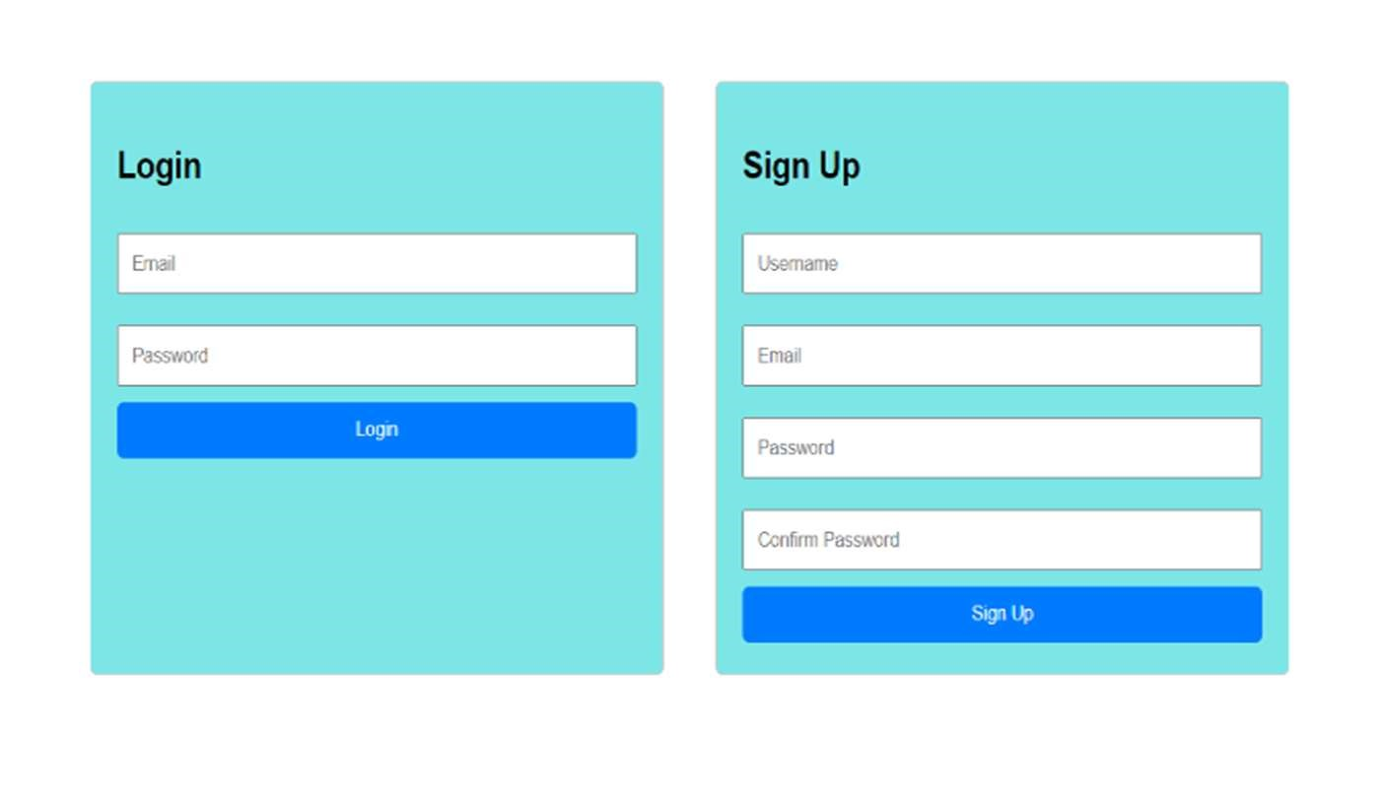

Figure 7.1 Sign-up and login Page

1. **User Management Module:**

Manages user-related functionalities such as profile management, online status tracking, and user interactions.

Facilitates user search, blocking/unblocking users, and managing user connections.

1. **Messaging Module:**

* Enables real-time communication between users.
* Facilitates sending and receiving messages, displaying message history, and supportingmultimedia messages.
* Ensures efficient message delivery and synchronization across multiple users.

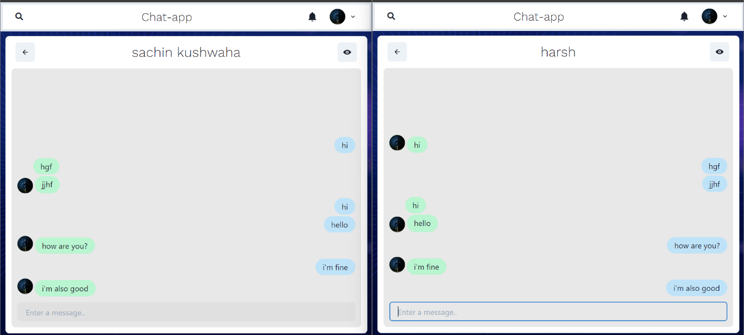

Figure 7.1.2 Chatting Interface

1. **Notification Module:**

* Handles the delivery of notifications to users about various events within the chat application.
* Provides notifications for new messages, mentions, system updates and other relevant events.
* Ensures users stay informed and engaged with the chat application.

1. **Settings Module:**

* Allows users to customize their chat application preferences according to their preferences and requirements.
* Provides options for managing notification settings, appearance settings, privacy settings, and account settings.
* Enhances user experience by providing flexibility and personalization options.

**7.2 Key Findings**

The key findings of a project on a real-time chat application could include:

1. User Preferences: Understanding user preferences regarding interface design, features, and usability to tailor the application to their needs and preferences.
2. Performance Metrics: Evaluating the application's performance metrics such as latency, message delivery time, and server response time to ensure optimal user experience.
3. Security Vulnerabilities: Identifying potential security vulnerabilities such as data leaks, unauthorized access, or encryption weaknesses to address and mitigate risks.
4. Scalability Challenges: Recognizing scalability challenges such as handling large user volumes or peak loads and devising strategies to accommodate growth without sacrificing performance.
5. User Engagement: Analyzing user engagement metrics such as active users, message frequency, and retention rates to measure the application's success and identify areas for improvement.
6. Integration Efforts: Assessing the integration efforts with third-party services or platforms to enhance functionality and provide seamless user experiences.
7. Feedback and Iteration: Incorporating user feedback and iterating on the application based on user suggestions or complaints to continuously improve the product.
8. Competitive Analysis: Conducting a competitive analysis to benchmark against other real-time chat applications, identifying strengths, weaknesses, and opportunities for differentiation.
9. Compliance Requirements: Ensuring compliance with relevant regulations and standards such as data protection laws or industry-specific requirements to maintain trust and legality.
10. Emerging Technologies: Exploring emerging technologies such as AI-driven chatbots, AR/VR integration, or blockchain-based security solutions to stay ahead of trends and innovate the application.

**7.3 Brief Description of Database**

In a real-time chat application using MongoDB as the backend database, you would typically have several collections to store different types of data related to the chat functionality. Here's a representation of how the backend might be structured

1. **Users Collection:**

Store user profiles and authentication data.

Fields include:

* _id: Unique identifier for the user.
* username: Username of the user.
* email: Email address of the user.
* password: Hashed password for authentication.

1. **Conversations Collection:**

Store information about individual conversations or chat rooms.

Fields may include:

* _id: Unique identifier for the conversation.
* participants: Array of user IDs participating in the conversation.
* type: Type of conversation (e.g., one-on-one, group).
* created_at: Timestamp indicating when the conversation was created.

1. **Messages Collection:**

Store the actual chat messages exchanged between users.

Fields may include:

* _id: Unique identifier for the message.
* conversation_id: Reference to the conversation this message belongs to.
* sender_id: ID of the user sending the message.
* content: Text content of the message.
* timestamp: Timestamp indicating when the message was sent.

**CHAPTER 8**

**CONCLUSION AND FUTURE SCOPE**

**8.1 Conclusion**

Developing a chat application using the MERN stack has proven to be both demanding and gratifying. Leveraging MongoDB, Express, React, and Node.js offers a robust foundation for crafting dynamic communication platforms adaptable to various needs and industries. Prioritizing user experience, features like real-time message updates and secure authentication contribute to a seamless communication environment. The scalability and resilience of the MERN stack ensure efficient handling of user traffic and messages without sacrificing performance. Looking ahead, there are ample opportunities for further enhancements such as incorporating video and voice chat, interoperability with other applications, and refining the interface for enhanced usability. Ultimately, the MERN-based chat application signifies a notable advancement in real-time communication and collaboration, potentially reshaping online connectivity and interaction paradigms

**8.2 Future Scope**

Looking ahead, the chat app can amp up security with stronger protection for user data. Fun AR features could make virtual meetings more exciting. Adding voice and video calls can make chatting more lively. Advanced tools like shared document editing could help with work or school projects. Making sure the app works on all devices will help everyone use it. Finding ways to make money, like offering extra features for a fee, can keep the app growing. Building communities within the app and letting it control smart devices can make it even more useful. Studying how people use the app can guide future improvements**Top of Form**

**REFERENCES**

1. S. Sharma and R. Jain, "Development of real-time chat application using MEAN stack," International Journal of Computer Applications, vol. 160, no. 8, pp. 35-38, 2017.
2. R. Shah, H. Gajera, and V. Patel, "Real-time chat application with MongoDB and Node.js," in 2019 4th International Conference on Internet of Things: Smart Innovation and Usages (IoTSIU), pp. 1-6, 2019, doi: 10.1109/IoT-SIU.2019.8776761.
3. K. Trabelsi and L. Ben Romdhane, "A real-time chat application using React and Firebase," in 2020 2nd International Conference on Data Science and Cloud Computing (DSCC), pp. 16, 2020, doi: 10.1109/DSCC50207.2020.9212061.
4. A. Patil and P. Yadav, "Design and development of real-time chat application using MEAN stack," in 2018 International Conference on Current Trends towards Converging Technologies (ICCTCT), pp. 1-4, 2018, doi: 10.1109/ICCTCT.2018.8550861.
5. A. Hameed, S. Hassan, and M. Sher, "Building a real-time chat application using Angular 7 and Firebase," International Journal of Advanced Computer Science and Applications, vol. 10, no. 9, pp. 282-287, 2019.
6. K. S. Prasad and R. Kumari, "Implementation of real-time chat application using Node.js," International Journal of Computer Applications, vol. 169, no. 8, pp. 1-5, 2017.
7. A. Bhardwaj and S. Singh, "Real-time chat application using WebSockets," International Journal of Computer Applications, vol. 180, no. 3, pp. 16-19, 2018.
8. R. Kumar and K. Singh, "Security issues in real-time chat applications: A review," in 2020 11th International Conference on Computing, Communication and Networking Technologies (ICCCNT), pp. 1-7, 2020, doi: 10.1109/ICCCNT49239.2020.9225286.
9. A. Rakesh and R. Kumar, "Scalability issues in real-time chat applications: A review," in 2018 Second International Conference on Computing Methodologies and Communication (ICCMC), pp. 350-354, 2018, doi: 10.1109/ICCMC.2018.8488121.
10. Y. Wang, J. Li, and Z. Zhang, "Real-time chat application development based on WebSocket and Node.js," in 2016 2nd IEEE International Conference on Computer and Communications (ICCC), pp. 2629-2632, 2016, doi: 10.1109/CompComm.2016.7924993.
11. R. Patel and V. Suryavanshi, "Real-time chat application using WebRTC," International Journal of Computer Applications, vol. 179, no. 26, pp. 23-26, 2018.
12. J. Agarwal and S. Gupta, "A study of real-time chat applications in IoT," in 2019 International Conference on Smart Systems and Inventive Technology (ICSSIT), pp. 729-732, 2019, doi: 10.1109/ICSSIT.2019.8988010.
13. H. Jain and R. Sharma, "Secure real-time chat application using end-to-end encryption," in 2020 International Conference on Advanced Computing and Intelligent Engineering (ICACIE), pp. 1-4, 2020, doi: 10.1109/ICACIE51054.2020.9330814.
14. P. Gupta and S. Verma, "Real-time chat application using Flutter and Firebase," International Journal of Advanced Research in Computer Science, vol. 11, no. 3, pp. 1-5, 2020.
15. A. Yadav and R. Singh, "Performance evaluation of real-time chat applications using different frameworks," in 2021 International Conference on Recent Advances in Information Technology (RAIT), pp. 1-6, 2021, doi: 10.1109/RAIT.2021.9481707.

**Patent publication**

